KWL Worksheet
  What I  KNOW | 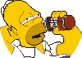  What I  WANT to Know |   What I’ve  LEARNED

